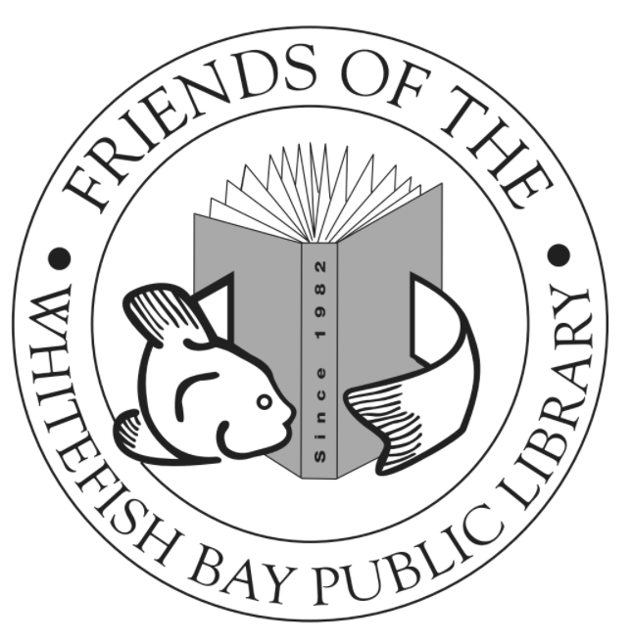

**2022 Friends of the Whitefish Bay Public Library Scholarship Application**

Deadline: March 15, 2022

Name: _______________________________________________________________________________

Home Address: ________________________________________________________________________

Phone Number: ________________________________________________________________________

Email Address: ________________________________________________________________________

Current High School (if applicable):_________________________________________________________

Are you currently a high school senior? (circle one) YES NO

Are you a resident of or go to high school in Whitefish Bay? (circle one) YES NO

Will you be attending an accredited two or four-year college or university as a full or part-time student for the 2022/2023 school year? (circle one) YES NO

**Scholarship Essay:** Please attach to this application a 400-word original essay describing how libraries have helped you achieve your academic goals or influenced your personal life. The quality of this essay is the main consideration for this scholarship.

This completed application and your essay should be returned to the Whitefish Bay Public Library in one of the following two ways:

* Email to: friendswfblibrary@gmail.com
* Mail to:

**ATTN: Scholarship**

**Friends of the Whitefish Bay Public Library**

**5420 N Marlborough Drive**

**Whitefish Bay, WI 53217**